School Lending Library

Cover image |  | Description | Suitable for | Type
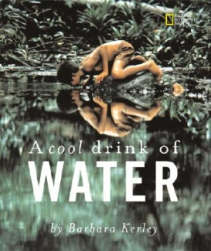 |  | A Cool Drink of Water  Barbara Kerley  This lyrical text is paired with stunning National Geographic photographs showing people all over the world enjoying water, drinking water to live, carrying and storing water as a precious resource. | Primary | Book  Non-fiction
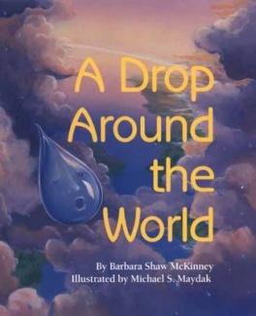 |  | A Drop Around the World  Barbara Shaw McKinney  This book engagingly leads readers around the world following a drop of water - whether as steam or snow, inside a plant or animal, or underground - teaching the wonders and importance of the water cycle. | Primary | Story Book
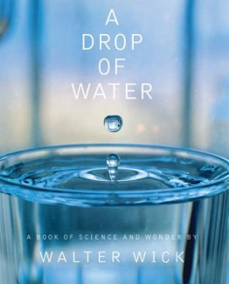 |  | A Drop of Water  Walter Wick  The most spectacular photographs ever created on the subject of water appear in this unique science book by Walter Wick. The camera stops the action and magnifies it so that all the amazing states of water can be observed - water as ice, rainbow, stream, frost, dew. | Primary | Book  Non-fiction
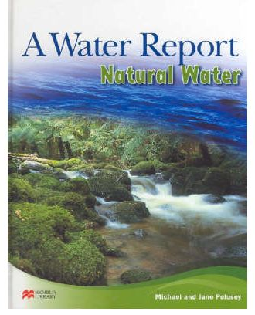 |  | A Water Report - Natural Water  Michael & Jane Pelusey  Natural Water reports on the availability of fresh water which is essential for life. It is a precious and limited resource and its conservation is a pressing concern for all of us. | Primary | Reference book
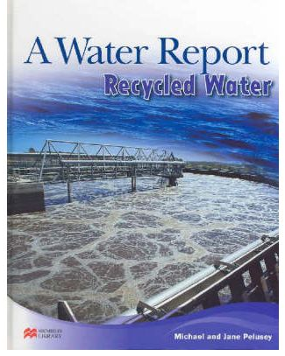 |  | A Water Report - Recycled Water  Michael & Jane Pelusey  Recycled Water reports on ways to recycle stormwater, waste water and sea water. | Primary | Reference book
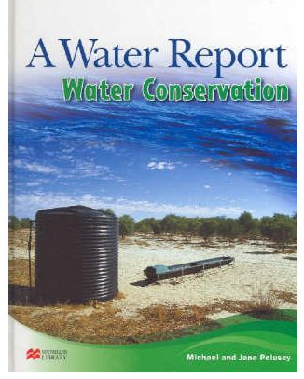 |  | A Water Report - Water Conservation  Michael & Jane Pelusey  Water Conservation reports on ways we can all conserve our water supply. | Primary | Reference book
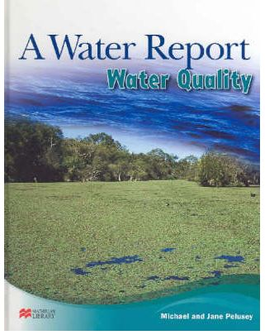 |  | A Water Report - Water Quality  Michael & Jane Pelusey  Water Quality reports on what affects the supply of good quality water which is essential for life. | Primary | Reference book
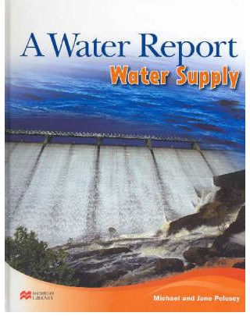 |  | A Water Report - Water Supply  Michael & Jane Pelusey  Water Supply reports on ways to manage our limited water supply. | Primary | Reference book
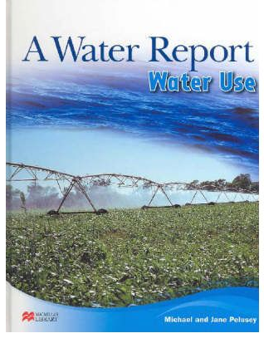 |  | A Water Report - Water Use  Michael & Jane Pelusey  Water Use reports on the different ways we use water, a resource essential for life. | Primary | Reference book
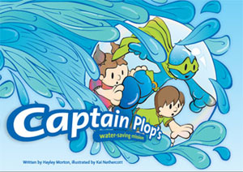 |  | Captain Plop's Water-Saving Mission  Hayley Morton  This book supports students to understand the importance of water conservation. The story introduces simple tips for saving water around the home. | Primary | Story Book
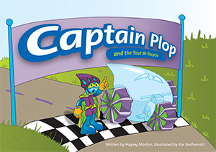 |  | Captain Plop and the Tour de Recycle  Hayley Morton  This is the latest book in the series and uses a cycling race theme to introduce primary students to the concept of treating and recycling wastewater. | Primary | Story Book
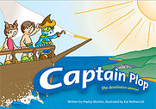 |  | Captain Plop the desalination adventure  This book takes students through the desalination process from the ocean to your tap at home | Primary | Story Book
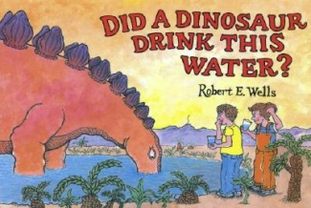 |  | Did a Dinosaur Drink this Water  Robert E Wells  The author explains the complete water cycle and also discusses ocean currents, ocean and lake habitats, and hydroelectricity. He also touches on water pollution and our responsibility to keep our water clean. | Primary | Story Book
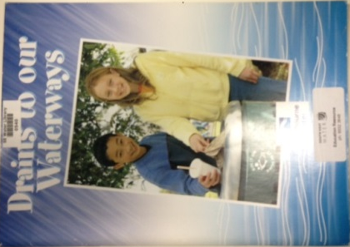 |  | Drains to our Waterways  Melbourne Water  This is a comprehensive learning resource on the impact of litter and pollution on our waterways. Based on the inquiry learning model, this education kit comprises a 10 minute video and a 64 page booklet. | Teacher resource, Middle years | Activity Book & CD
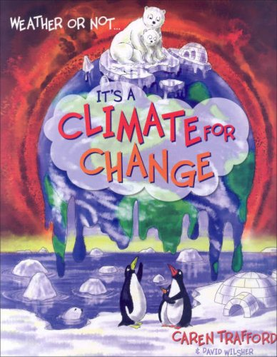 |  | Weather or Not It’s a Climate for Change  Caren Trafford  A fun, fact finding, educational guide to global warming. | Primary | Book  Non-fiction
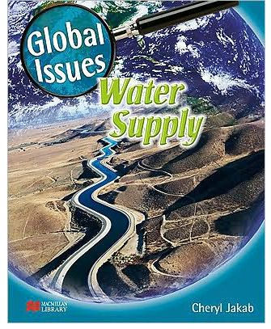 |  | Global Issues - Water Supply  Cheryl Jakab  Upper Primary students will explore issues focusing on the importance of maintaining water supplies. It explores the key issues relating to low water supplies and outlines the problems and offers solutions for a sustainable future. | Upper Primary | Book  Non-fiction
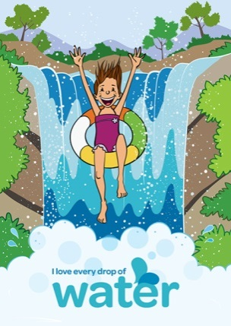 |  | I Love Every Drop of Water  South East Water  Water is the essence of life and our lifestyle. We depend on it for our health and wellbeing. It’s the lifeblood of our homes, our community, our schools, our industry and the environment we all live in. | Primary | Story Book
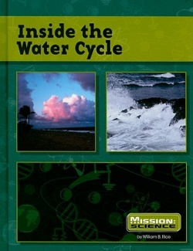 |  | Inside the Water Cycle  William B. Rice  No matter where you live on Earth, the water cycle plays an important role. Nothing on Earth can survive without water. The water cycle is a fascinating process that makes our planet unique. | Primary | Reference book
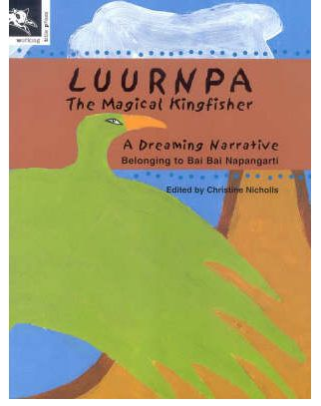 |  | Luurnpa The Magical Kingfisher  Bai Bai Napangarti  This is a traditional Abouriginal Dreamtime narrative belonging to Bai Bai Napangarti from the Balgo Hills region of Western Australia. It tells the story of Luurnpa, who saves the Kukatja people from dying of thirst by showing them this magic rock hole full of water. | Lower Primary | Story  Book
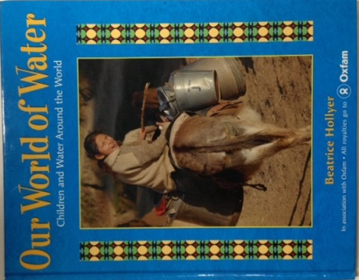 |  | Our World of Water - Children and water Around…  Beatrice Hollyer  This book follows the daily lives of six children from Peru, Mauritania, Bangladesh, Ethiopia, Tajikistan and California and explores what water means to them. | Primary | Book  Non-fiction
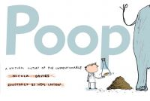 |  | Poop – The Natural History of the unmentionable  Nicola Davies & Neal Layton  Hippos navigate by it, sloths keep in touch through it, dung beetles eat it…and most grown-ups would rather not mention it. Take a peek at POOP and find out all you need to know – what’s it for, where it goes and how much we can learn from it. | Primary | Book  Non-fiction
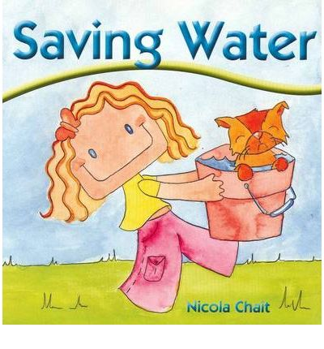 |  | Saving Water  Nicola Chait  This beautifully illustrated board book shows young children how they can make a difference to the world through water conservation. | Lower Primary | Board book
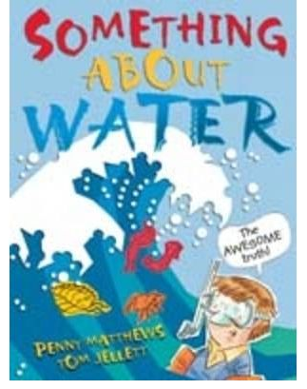 |  | Something About Water  Penny Matthews & Tom Jellett  As Robbie learns about the importance of water, he becomes interested in saving the planet. He might only be contributing in a small way, but small things can make a big difference. Along the way, Robbie discovers some fascinating facts about water. | Primary | Story Book
 |  | Something About Water Teacher Notes  Linnet Hunter  These teacher notes will give you ideas for discussion and activities to complete when reading Something About Water with your class. | Teacher Resource
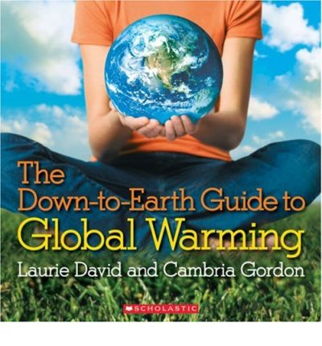 |  | The Down-To-Earth Guide to Global Warming  Laurie David & Cambria Gordon  This essential guide will help you understand why global warming happens, how it affects the plant and the simple steps you can take to get involved in protecting the environment. | Upper Primary/  Secondry | Book  Non-fiction
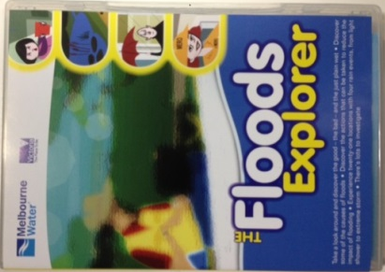 |  | The Floods Explorer  Melbourne Water  Using the animated Floods Explorer, students can explore what happens when it rains in urban areas, how houses and parks are affected and the consequence of blocked gutter and stormwater pollution. | Middle years | CD
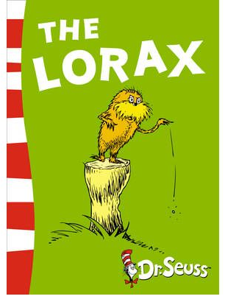 |  | The Lorax  Dr Seuss  "Unless someone like you...cares a whole awful lot...nothing is going to get better...It's not." The Lorax struggles to save all the Truffula Trees from the wicked Once-ler’s axe. | Primary | Story Book
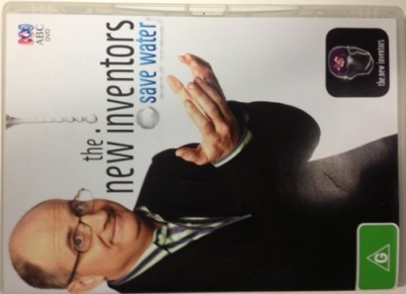 |  | The New Inventors - Save Water  James O'Loghlin  This compilation features some of the best water saving devices that have been showcased on New Inventors. Running time 106 minutes. | Secondary | DVD
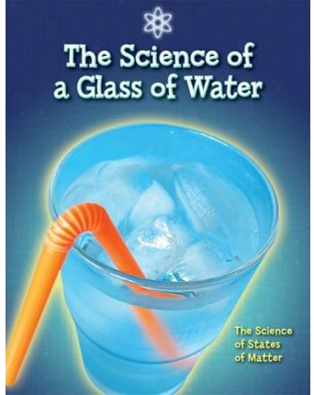 |  | The Science of a Glass of Water  Anna Claybourne  Dive into the Science of a glass of water to learn what water is, how we use it and why our world may be running dry. | Primary | Book  Non-fiction
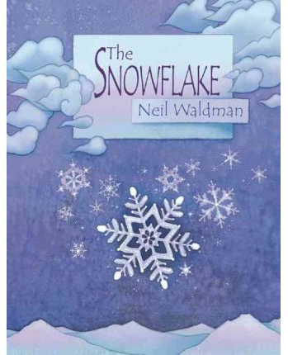 |  | The Snowflake - A Water Cycle Story  Neil Waldman  A simple, poetic text and elegantly expressive illustrations chart the yearlong course of one water droplet and ends with thought provoking musing about water. | Lower Primary | Story Book
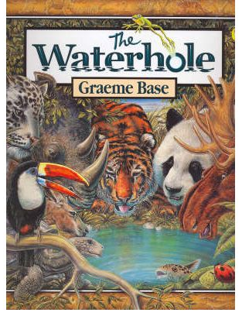 | The Waterhole  Graeme Base  The creator of Animalia brings a stunning new picture book with an exquisite cast of characters and a timeless, life-affirming theme. |  | Lower Primary | Story Book
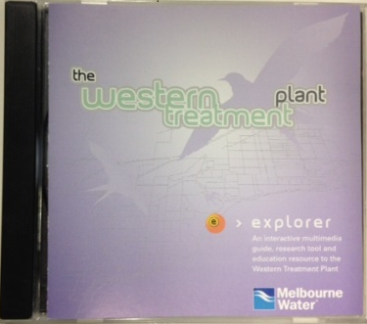 | The Western Treatment Plant  Melbourne Water  This CD-ROM contains an interactive multimedia guide and teaching and learning materials to the Western Treatment Plant. |  | All | CD
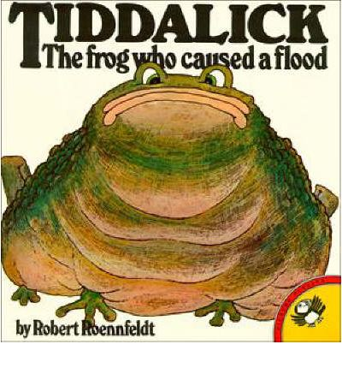 | Tiddalick - The frog who caused a flood  Robert Roenfeldt  Based on an aboriginal legend, this book aims to teach water conservation and care for our environment. |  | Lower Primary | Story Book
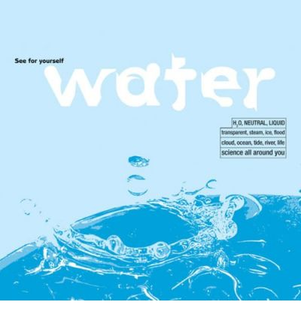 | Water  Trevor Day  Incredible images and amazing facts and features show you how water shapes our planet and how vital it is to Earth’s future. |  | Primary | Book
 | Water – learn it. live it.  Volume 1: Water in the natural environment  Water – learn it. live it. is a joint initiative of South East Water, City West Water and Yarra Valley Water. This resource allows students to explore water through Science, English, Geography, Maths, Music and Art activities. This volume is broken into four sections: Properties of Water, Natural Water Cycle, Bodies of Water and Weather. |  | Primary/  Secondary | Teacher Resource
 | Water – learn it. live it.  Volume 2: Water in the urban environment  Look at the journey water takes through the urban water cycle. This volume is broken into four sections: Collecting Water, The Water Journey, Water Coming and Going and Water Industry. |  | Primary/  Secondary | Teacher Resource
 | Water – learn it. live it.  Volume 3: Water in the community  Find out about the ways we use, consume and value water. This volume is broken into five sections: Understanding Water Use, How We Use Water, Water Meanings, Water Supply and Efficient Water Use and Water for Health and Wellbeing. |  | Primary/  Secondary | Teacher Resource
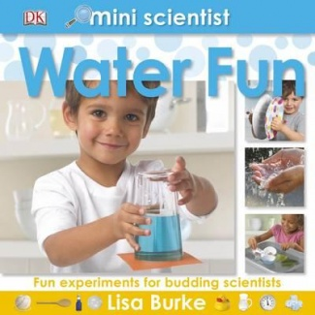 | Mini Scientist Water Fun  Lisa Burke  Fun experiments to do with water, packed with cool and wet experiments. Simple instructions encourage children to watch, take notes, collect things and observe changes, helping them learn about science as they play. |  | Primary | Reference book
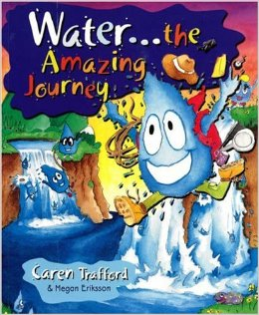 | Water…the Amazing Journey  Caren Trafford and Megan Eriksson  Meet Wasu and discover water’s view on life. Follow the water cycle, travel throughout the ages and discover things you never knew. |  | Primary | Story Book
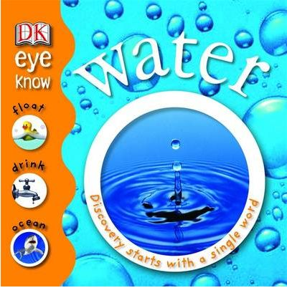 | Water- Discovery Starts with a Single Word  Penelope Arlon  Learning about water is introduced from a starting point that children will already know, encouraging them to find out about their daily life and the world around them. |  | Lower Primary | Book
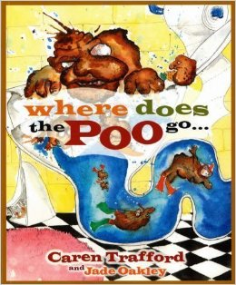 | Where Does the Poo Go?  Caren Trafford and Jade Oakley  Follow Goobie, as he takes us on a fascinating journey from the beginning of time. Who do they see? What do they do? Where do they go in the quest to be recycled? |  | Primary | Story Book
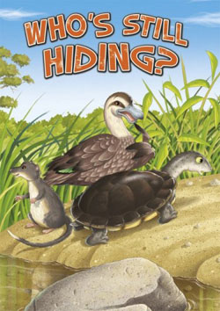 | Who’s Still Hiding Big Book  Melbourne Water  'Who’s still hiding?' is a picture storybook for beginning readers. This delightful book helps younger students discover the animals that call our rivers and creeks home. |  | Lower Primary | Story book
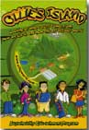 | Ollie’s Island  Ollie’s World.com  Ollie’s Island is an interactive multimedia educational program that provides an understanding and appreciation of the full chain of production and consumption for everything we need in life. |  | Middle to Upper Primary | CD-Rom
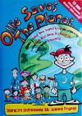 | Ollie Saves the Planet  Ollie’s World.com  This CD-Rom explores the 4R’s – Reduce, Reuse, Recycle and Rethink as they apply to the five action issues of Waste, Water, Air and Biodiversity. It is full of games, puzzles and loads of information. |  | Middle to Upper Primary | CD-Rom
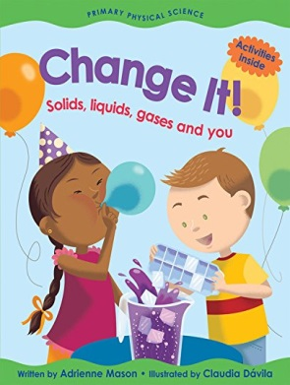 | Change It! Solids, liquids, gases and you  Adrienne Mason  Change It! takes the physics of matter --- solids, liquids and gases --- and transforms it into an enjoyable and easy-to-understand first science book. |  | Lower primary | Reference book

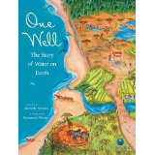 | One Well: The Story of Water on Earth  Rochelle Strauss  All water is connected. Every raindrop, lake, underground river and glacier is part of a single global well.  One Well is part of CitizenKid: A collection of books that inform children about the world and inspire them to be better global citizens. | Upper Primary | Reference book
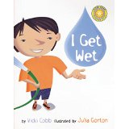 | I Get Wet  Vicki Cobb Science Play  Fun hands-on activities and irresistible illustrations by Julia Gorton make this book a perfect excuse to learn about science...just for the fun of it | Middle Primary | Story book
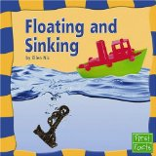 | Floating and Sinking  Ellen S. Niz  This book introduces the reader to the concepts of floating and sinking and how they ae used in the world. | Lower to Middle Primary | Story book
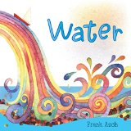 | Water  Frank Asch  Water is beautiful and useful and, in its many forms, vital to life. The book encourages young readers to appreciate anew one of our most precious resources. | Lower Primary | Story book
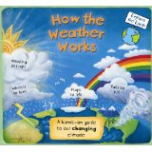 | How the Weather Works  Christiane Dorion & Beverley Young  This is an entertaining and enlightening exploration of the world s weather. With bright, friendly illustrations, plus pop-ups, pull-tabs, and booklets. | Middle to Upper Primary | Reference book

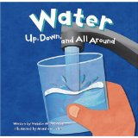 | Water – Up, Down and All Around  Natalie M. Rosinsky  This book describes the water cycle and the importance of water. Terms such as evaporation, condensation, water vapor and the three states of water are explained. | Lower to Middle Primary | Story book
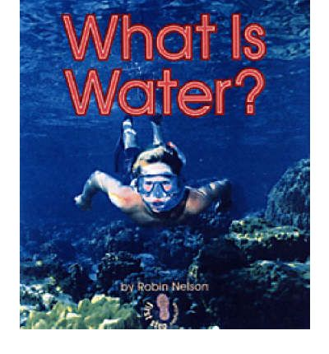 | What is Water?  Robin Nelson  Easy to read book about what is water. | Lower primary | Story book
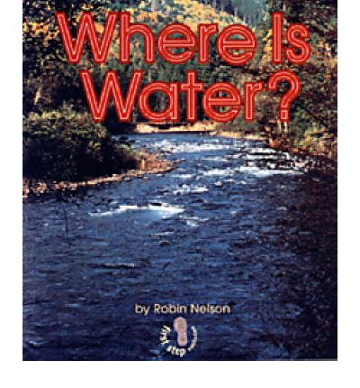 | Where is Water?  Robin Nelson  Easy to read book about where water can be found. | Lower  Primary | Story book
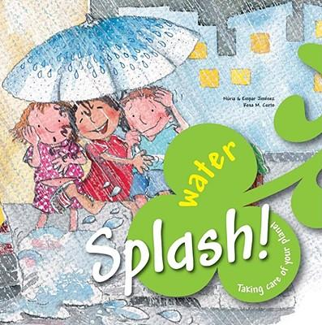 | Splash! Water  Taking Care of Your Planet  Nuria Jimenez, Empar Jimenez  This book helps children understand the importance of water and how to conserve water in our homes. | Middle to  Upper  Primary | Story book
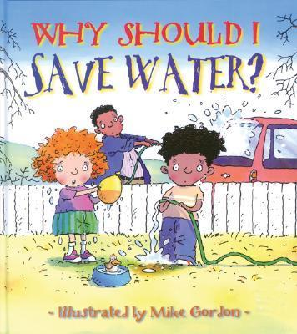 | Why Should I Save Water?  Jen Green  This book teachers children that water is our most precious natural recourse and shows them ways to avoid wasting water. | Lower to  Middle  Primary | Story book
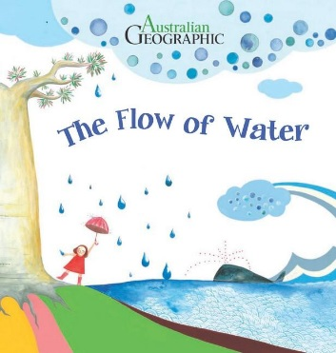 | The Flow of Water  Da-jeong Yu  This books helps kids understand the different forms of water and how water moves around our planet. | Lower  Primary | Story book
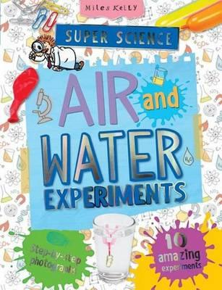 | Air and Water Experiments  Chris Oxlade  Fun activities to do with air and water. | Upper  Primary | Activity book
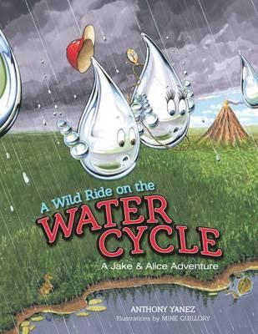 | A Wild Ride on the Water Cycle  Anthony Yanez  Teachers the kids the science behind the water cycle. | Upper  Primary | Story book
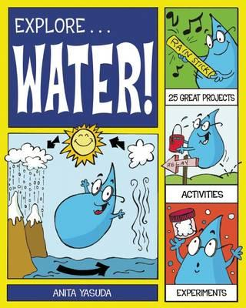 | Explore…Water!  Anita Yasuda  Provides hands-on activities with history and science to teach kids about the water cycle, water resources, drinking water and sanitation and water pollution and conservation. | Upper  Primary | Activity book
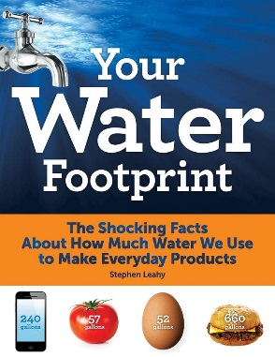 | Your Water Footprint  Stephen Leahy  Teachers kids about how much water we use in day to day life | Upper  Primary | Book  Non-fiction
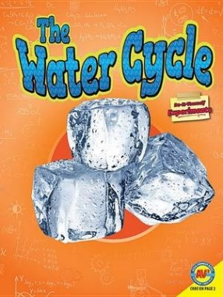 | The Water Cycle- Do it Yourself Experiments  Shirley Duke  Do it yourself science experiments with clear step by step instructions. | Middle to Upper Primary | Activity book
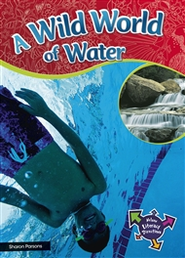 | A Wild World of Water  Sharon Parsons  Water is an incredibly valuable resource that everyone needs to look after. ... Take a deep breath, then dive into the wild world of water | Middle to  Upper Primary

